

AMERICAN INTERNATIONAL UNIVERSITY–BANGLADESH (AIUB)
Dept. of Computer Science
Faculty of Science and Technology
CSC2210: OBJECT ORIENTED PROGRAMMING 2
Spring 2025-2026
Section: M
Group No: 102

Project Report On
Multi-Vendor E-Commerce System
Supervised By
Dr. Md. Iftekharul Mobin

Submitted By:
Name | ID
1. A.H.M. NAZMUS SAKIB | 24-60434-3
2. JANNATUL EYAMIN | 24-57735-2
3. N/A | N/A
Obtained Marks for CO2 and CO3 (Description given in the following page)
Assessment  Criteria | Not Attended/ Incorrect (0) |  | Inadequate  (1-2) |  | Average  (3) | Good  (4) | Excellent  (5)
Evaluation Criteria (CO2) |  | Total = |  | Evaluation Criteria (CO3) |  |  | Total =
Requirement fulfillment |  |  |  | Organization of the application
Validation |  |  |  | Representation and Integration of Database
Verification |  |  |  | Graphical User Interface

CO2: Display and verify the mean of a real-life Project using the concepts of C# Graphical User Interface based environment with database integration to depict a desktop-based application.
Assessment  Criteria | Not Attended/ Incorrect (0) | Inadequate  (1-2) |  | Average  (3) |  | Good  (4) |  | Excellent  (5)
Evaluation Criteria | Evaluation Definition
Requirement fulfillment | Fails to demonstrate any understanding of real-life scenario-based project development or functional requirement identification. There is no attempt to depict a project or identify functional requirements accurately. |  | Demonstrates limited understanding of real-life scenario-based project development and functional requirement identification. The project depicted lacks coherence or relevance to real-life scenarios, and functional requirements are inaccurately identified or insufficiently described. |  | Presents a basic depiction of a real-life scenario-based project and identifies some functional requirements. However, the project lacks depth or complexity, and some functional requirements may be vaguely defined or missing key details. |  | Effectively demonstrates a realistic scenario-based project and accurately identifies most functional requirements. The project is well-developed with appropriate complexity, and functional requirements are clearly articulated with relevant details. |  | Exhibits an exceptional understanding of real-life scenario-based project development and accurately identifies all functional requirements. The project is meticulously developed with thorough attention to detail, reflecting a comprehensive understanding of Object-Oriented Programming project development activities.
Validation | Fails to demonstrate any understanding or implementation of validation forms in their system. There is no attempt to deal with data validation, and validation requirements are completely ignored or incorrectly applied. |  | Demonstrates limited understanding of validation forms and data validation techniques. While some attempt may be made to implement validation, it is incomplete or poorly executed, leading to inadequate handling of data validation. |  | Shows a basic understanding of validation forms and data validation techniques. They attempt to implement validation, but some aspects may be missing or incorrectly implemented, resulting in partial or inconsistent handling of data validation. |  | Effectively demonstrates the use of validation forms and implements data validation techniques. Validation is mostly accurate and comprehensive, ensuring the proper handling of data input and verification in the system. |  | Exhibits an exceptional understanding and implementation of validation forms and data validation techniques. Validation is meticulously implemented with thorough attention to detail, ensuring robust data validation procedures and contributing to the overall reliability and integrity of the system.
Verification | Fails to demonstrate any attempt to verify the system data or functional requirements. There is no evidence of understanding or implementation of verification processes, and data flow is not considered. |  | Demonstrates limited understanding of verification processes and data flow in the system. Verification attempts are incomplete or inaccurate, and there is insufficient consideration given to ensuring data integrity and functionality. |  | Shows a basic understanding of verification processes and attempts to verify system data. However, verification efforts may be inconsistent or lack thoroughness, and there may be gaps in ensuring proper functional requirements and data flow. |  | Identifies and verifies system data, ensuring proper functional requirements are met. Verification efforts are mostly accurate and thorough, with attention to ensuring data integrity and appropriate data flow within the system. |  | Exhibits an exceptional understanding of verification processes and meticulously verifies system data. Verification efforts are comprehensive and precise, with a keen focus on ensuring all functional requirements are met and maintaining proper data flow throughout the system.

CO3: Prepare and explain a real-life desktop-based application synthesizing several components of C# along with development tools to adhere the given requirements.
Assessment  Criteria | Not Attended/ Incorrect (0) | Inadequate  (1-2) |  | Average  (3) |  | Good  (4) |  | Excellent  (5)
Evaluation Criteria | Evaluation Definition
Organization of the application | Fails to identify any suitable real time application or requirements for project development activities related to OOP. |  | Limited understanding about the project scopes and scenarios or identification of functional requirements. |  | Lacks depth or relevance to OOP project development activities and may contain inaccuracies. Real-life scenarios are mentioned, but the discussion lacks depth or clarity. |  | Consider and integrate the idea of several core aspects of the project along with relevance to real-life scenarios. Demonstrating a solid understanding of the application presentation. |  | Generalize and exhibits an exceptional understanding of project preparation according to a to real-life scenarios. Also contains proper and insightful identification of the system which is comprehensive and precise.
Representation and Integration of Database | Fails to identify and present any understanding or implementation of database. Also failed to integrate the data with the project itself. |  | Limited understanding of the database concepts or their proper way of using in a real time project. While some attempt may be made to implement but it is incomplete or poorly executed, leading to inadequate design. |  | Lacks depth or relevance to database integration with the application. Shows a basic understanding but some aspects may be missing or incorrectly implemented, resulting in partial or inconsistency. May lack proper normalization. |  | Integrate the database with the forms properly and implements it with proper validation which is mostly accurate and comprehensive, ensuring the proper handling of data input and verification along with general normalization. |  | Exhibits an exceptional understanding and implementation of databases ensuring attention to detail, and robust data manipulation procedures and contributing to the overall clarity.
Graphical User Interface | Fails to present or prepare GUI based application interfaces. There is no evidence of creating or integrating such things according to their usefulness. |  | Limited understanding of graphical user interfaces. Lack of design knowledge. Very poor attempt to make such things which are currently obsolete or can’t be identified as coherent. |  | Shows a basic understanding of creating user interfaces. Most of them are interconnected but maybe some of them lack it. However, most of it can be described as user friendly. |  | Effectively identify and meet the consider the simplicity. Design related works are mostly accurate and taken proper attention to ensuring a user-friendly coherent system. |  | Exhibits an exceptional work design following a high standard of simple and elegant work. Several controls and mechanisms have been organized in a preferred way according to the coherent usage.

Table of Contents: Page no.

1. Chapter :01 (Introduction)---------------------------------------------------------------------- 04
2. Chapter :02(User Story) ------------------------------------------------------------------------ 05
3. Chapter :03 (Schema Diagram) --------------------------------------------------------------- 07
4. Chapter :04 (SQL Queries) -------------------------------------------------------------------- 08
5. Chapter:05 (Screenshots) ---------------------------------------------------------------------- 11

Chapter 1: Introduction

The Multi-Vendor E-Commerce System (ShopHub) is a comprehensive desktop application developed using C#.NET Windows Forms and Microsoft SQL Server as the backend. Designed to facilitate decentralized online retail operations, the platform establishes an integrated digital marketplace where multiple independent merchants (Vendors) can register, manage, and sell their inventory, while buyers (Customers) can discover products, manage shopping carts, execute secure purchases, and rate items.
The application implements a robust, centralized administration hub where system administrators oversee user management, review merchant verification request lines, handle product categories, monitor platform transactions, and analyze business performance reports.

Key Features of the System:
- Role-Based Access Control (RBAC): Distinct administrative interfaces, business-management dashboards, and shopping portals tailored to three primary user classes: Administrators, Vendors, and Customers.
- Customer Shopping Lifecycle: Full checkout integration enabling product discovery (categorization, keyword queries), responsive in-memory cart operations, secure billing/shipping collection, stock level validation, and post-purchase item review systems.
- Vendor Inventory & Storefront Management: Real-time metrics overview, inventory CRUD capabilities, store detail personalization, and independent order fulfillment progression.
- Security & Audit Trails: Secure custom registration, password mutation layers, database-level reference integrity, and system-wide verification gates (such as Vendor storefront approvals).

Chapter 2: User Story

The system's features are defined by the following role-based user stories:
A. General / Anonymous User Stories
- Sign Up: As an anonymous user, I want to create an account as either a customer or a Vendor so that I can access the platform’s role-specific features.
- Login: As a registered user, I want to securely log in to the system with my credentials so that I can be redirected to my respective dashboard.
B. Customer User Stories
- Product Discovery: As a customer, I want to browse products, filter them by category, and search by keywords so that I can quickly find the items I wish to buy.
- Shopping Cart Management: As a customer, I want to add products to my cart, update quantities, and remove items so that I can manage my order before checking out.
- Checkout & Order Placement: As a customer, I want to place an order by providing my payment method and shipping address so that I can purchase my selected products.
- Order History: As a customer, I want to view my past orders, check their statuses, and inspect individual order details so that I can track my purchases.
- Product Reviews: As a customer, I want to leave a rating and review for products I have purchased so that I can share my feedback with other shoppers.
- Profile Personalization: As a customer, I want to update my personal profile details and change my password so that I can keep my account details secure.
C. Vendor User Stories
- Store Dashboard: As a vendor, I want to view analytics (total products, orders, revenue, and reviews) on my dashboard so that I can monitor my store’s performance.
- Inventory Control: As a vendor, I want to add, update, and delete my products so that my active inventory remains accurate and up to date.
- Fulfillment Tracking: As a vendor, I want to track customer orders containing my products and update their fulfillment status (e.g., Processing, Shipped, Delivered) so that buyers know their order progress.
- Sales Reporting: As a vendor, I want to run visual sales reports of my top-performing products by revenue and quantity so that I can identify sales trends.
- Store Customization: As a vendor, I want to modify my store details (e.g., store name, phone, address, description) so that my business details look professional to buyers.
D. Administrator User Stories
- Central Dashboard Overview: As an admin, I want to monitor platform metrics (total registered accounts, approved vendors, active items, complete orders, total revenue) so that I can assess the overall health of the marketplace.
- User Oversight: As an admin, I want to view, search, filter, and deactivate user profiles (customers, vendors, and admins) so that I can maintain platform integrity.
- Vendor Approval Board: As an admin, I want to approve or reject newly registered vendors so that only verified merchants can list products on the store.
- Category Management: As an admin, I want to create, modify, and delete product categories so that the marketplace catalog remains organized.
- Review Moderation: As an admin, I want to view and delete product reviews that violate guidelines so that the review system remains constructive and trustworthy.

Chapter 3: Schema Diagram
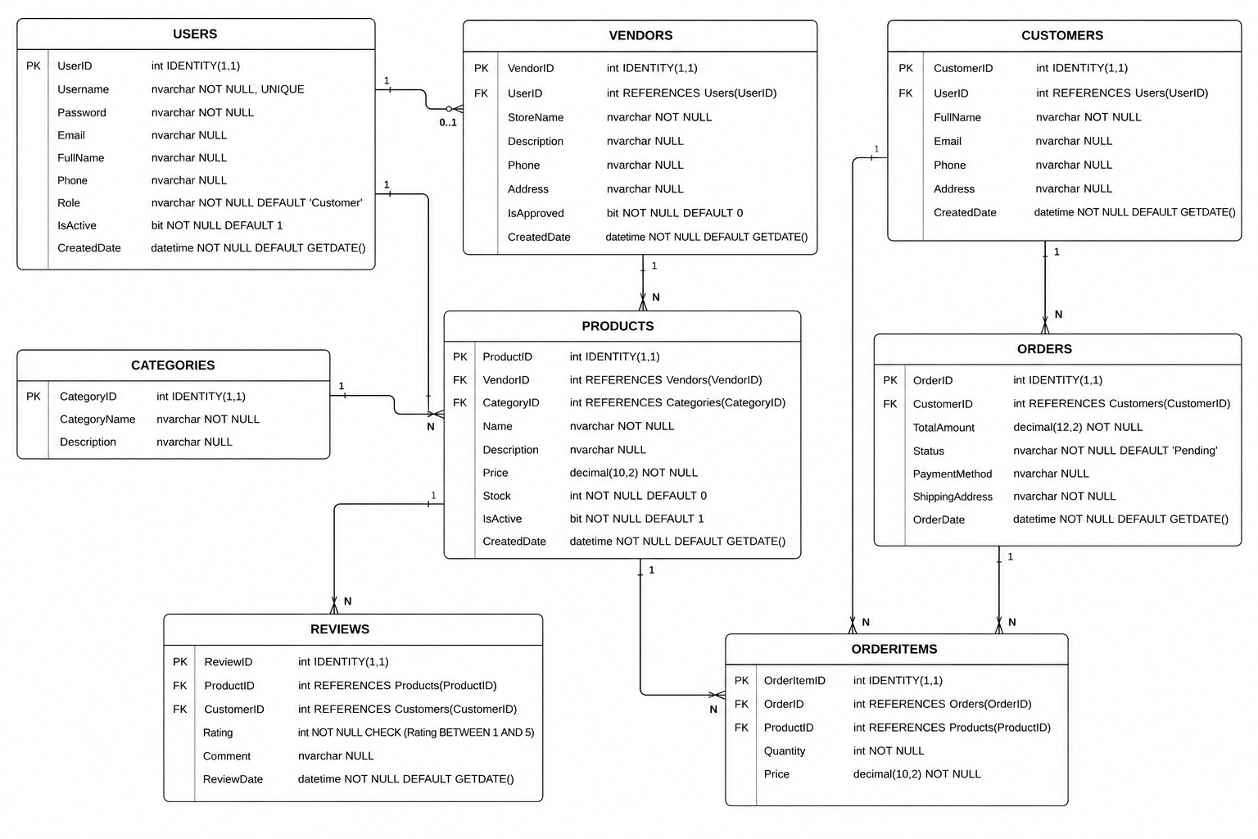

Chapter 4: SQL Queries

CREATE DATABASE MultiVendorDB;
GO
USE MultiVendorDB;
GO

CREATE TABLE Users (
UserID INT PRIMARY KEY IDENTITY (1,1),
Username NVARCHAR (50) NOT NULL UNIQUE,
Password NVARCHAR (100) NOT NULL,
Email NVARCHAR (100),
FullName NVARCHAR (100),
Phone NVARCHAR (20),
Role NVARCHAR (20) NOT NULL DEFAULT 'Customer',
IsActive BIT NOT NULL DEFAULT 1,
CreatedDate DATETIME DEFAULT GETDATE ()
);

CREATE TABLE Vendors (
VendorID INT PRIMARY KEY IDENTITY (1,1),
UserID INT FOREIGN KEY REFERENCES Users (UserID),
StoreName NVARCHAR (100),
Description NVARCHAR (300),
Phone NVARCHAR (20),
Address NVARCHAR (200),
IsApproved BIT DEFAULT 0,
CreatedDate DATETIME DEFAULT GETDATE ()
);

CREATE TABLE Customers (
CustomerID INT PRIMARY KEY IDENTITY (1,1),
UserID INT FOREIGN KEY REFERENCES Users (UserID),
FullName NVARCHAR (100),
Email NVARCHAR (100),
Phone NVARCHAR (20),
Address NVARCHAR (200),
CreatedDate DATETIME DEFAULT GETDATE ()
);

CREATE TABLE Categories (
CategoryID INT PRIMARY KEY IDENTITY (1,1),
CategoryName NVARCHAR (100) NOT NULL,
Description NVARCHAR (200)
);

CREATE TABLE Products (
ProductID INT PRIMARY KEY IDENTITY (1,1),
VendorID INT FOREIGN KEY REFERENCES Vendors (VendorID),
CategoryID INT FOREIGN KEY REFERENCES Categories (CategoryID),
Name NVARCHAR (150) NOT NULL,
Description NVARCHAR (500),
Price DECIMAL (10,2) NOT NULL,
Stock INT NOT NULL DEFAULT 0,
IsActive BIT NOT NULL DEFAULT 1,
CreatedDate DATETIME DEFAULT GETDATE ()
);

CREATE TABLE Orders (
OrderID INT PRIMARY KEY IDENTITY (1,1),
CustomerID INT FOREIGN KEY REFERENCES Customers (CustomerID),
TotalAmount DECIMAL (12,2),
Status NVARCHAR (30) DEFAULT 'Pending',
PaymentMethod NVARCHAR (50),
ShippingAddress NVARCHAR (300),
OrderDate DATETIME DEFAULT GETDATE ()
);

CREATE TABLE OrderItems (
OrderItemID INT PRIMARY KEY IDENTITY (1,1),
OrderID INT FOREIGN KEY REFERENCES Orders (OrderID),
ProductID INT FOREIGN KEY REFERENCES Products (ProductID),
Quantity INT NOT NULL,
Price DECIMAL (10,2) NOT NULL
);

CREATE TABLE Reviews (
ReviewID INT PRIMARY KEY IDENTITY (1,1),
ProductID INT FOREIGN KEY REFERENCES Products (ProductID),
CustomerID INT FOREIGN KEY REFERENCES Customers (CustomerID),
Rating INT NOT NULL CHECK (Rating BETWEEN 1 AND 5),
Comment NVARCHAR (500),
ReviewDate DATETIME DEFAULT GETDATE ()
);

-- Default Users
INSERT INTO Users (Username,Password,Email,FullName,Role,IsActive)
VALUES ('admin','admin123’, ‘admin@shop.com','Administrator','Admin',1);

INSERT INTO Users (Username,Password,Email,FullName,Role,IsActive)
VALUES ('vendor','vendor123’, ‘vendor@shop.com','Tech Vendor','Vendor',1);

INSERT INTO Users (Username,Password,Email,FullName,Role,IsActive)
VALUES ('customer','cust123’, ‘customer@shop.com','John Customer','Customer',1);

INSERT INTO Vendors (UserID,StoreName,Description,Phone,Address,IsApproved)
VALUES (2,'TechZone Store','Best electronics!','9876543210','123 Tech Street',1);

INSERT INTO Customers (UserID,FullName,Email,Phone,Address)
VALUES (3,'John Customer’, ‘customer@shop.com','9123456789','456 Customer Lane');

INSERT INTO Categories (CategoryName,Description) VALUES ('Electronics','Gadgets');
INSERT INTO Categories (CategoryName,Description) VALUES ('Clothing','Fashion');
INSERT INTO Categories (CategoryName,Description) VALUES ('Books','Education');
INSERT INTO Categories (CategoryName,Description) VALUES ('Home & Kitchen','Appliances');
INSERT INTO Categories (CategoryName,Description) VALUES ('Sports','Equipment');

INSERT INTO Products (VendorID,CategoryID,Name,Description,Price,Stock,IsActive)
VALUES (1,1,'Wireless Headphones','Bluetooth headphones',2499.00,50,1);
INSERT INTO Products (VendorID,CategoryID,Name,Description,Price,Stock,IsActive)
VALUES (1,1,'Smartphone X200','6.5-inch AMOLED',18999.00,30,1);
INSERT INTO Products (VendorID,CategoryID,Name,Description,Price,Stock,IsActive)
VALUES (1,2,'Cotton T-Shirt','Premium cotton',499.00,200,1);
INSERT INTO Products (VendorID,CategoryID,Name,Description,Price,Stock,IsActive)
VALUES (1,3,'Python Book','Complete Python guide',449.00,60,1);
INSERT INTO Products (VendorID,CategoryID,Name,Description,Price,Stock,IsActive)
VALUES (1,4,'Electric Kettle','1.5L kettle',1199.00,45,1);
GO

Chapter 5: Screenshots

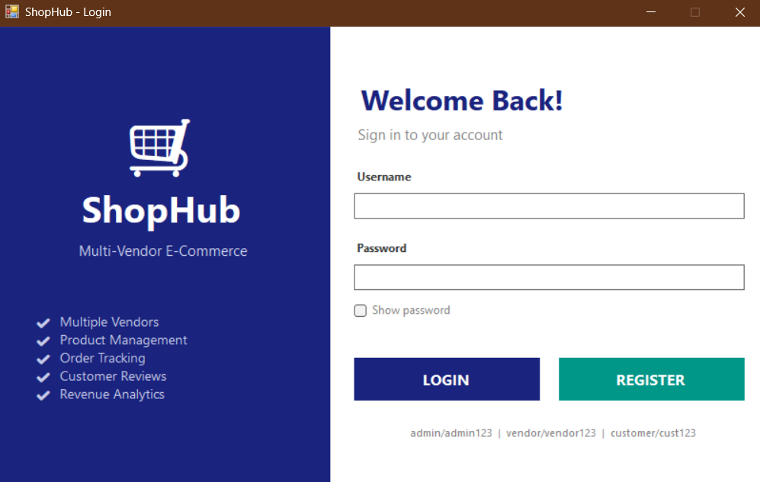
Figure 01: Login/Registration Panel

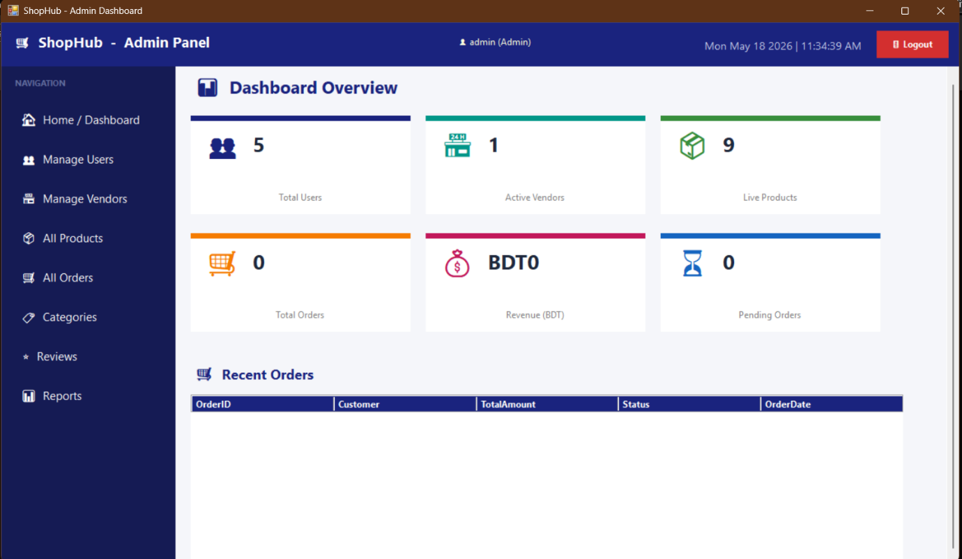
Figure 02: Admin Dashboard

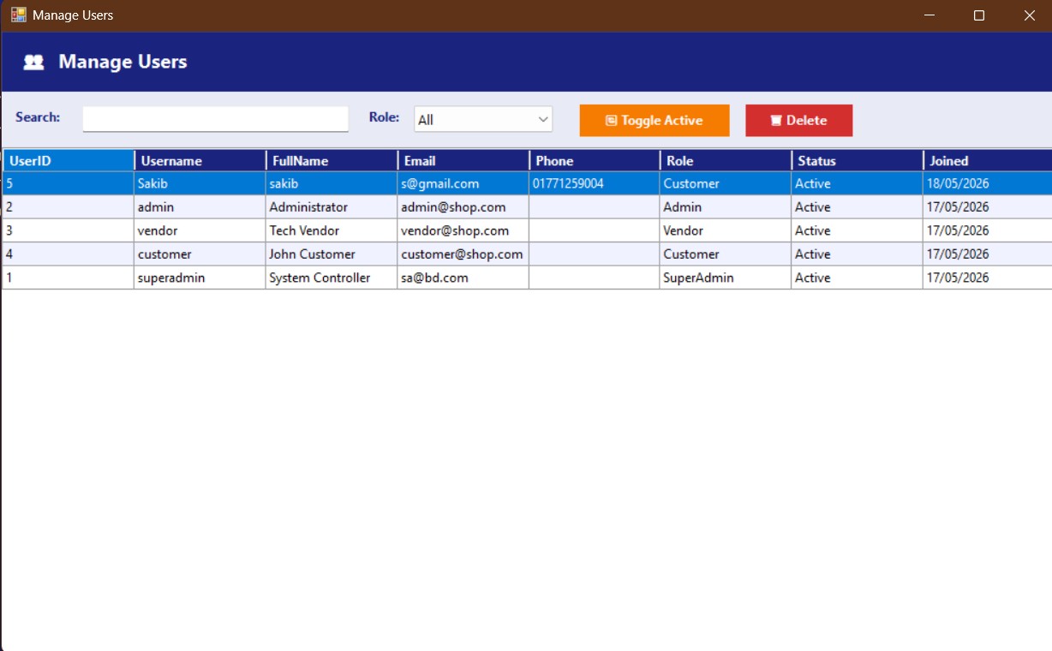
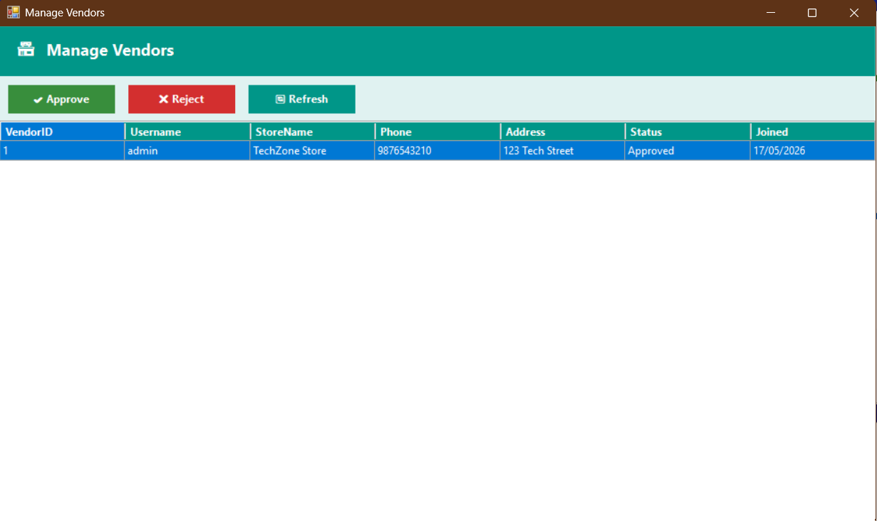
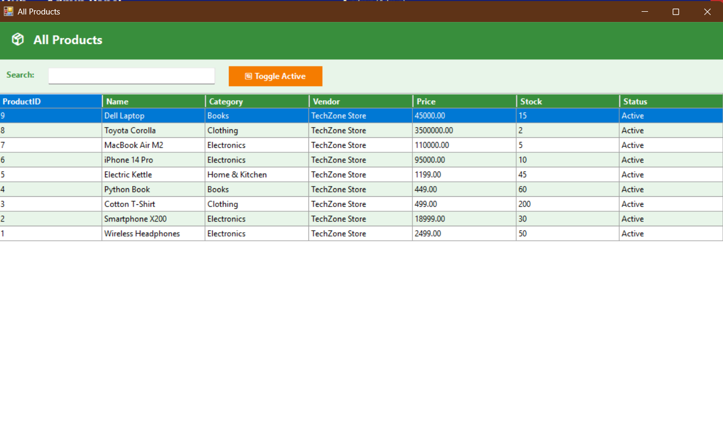
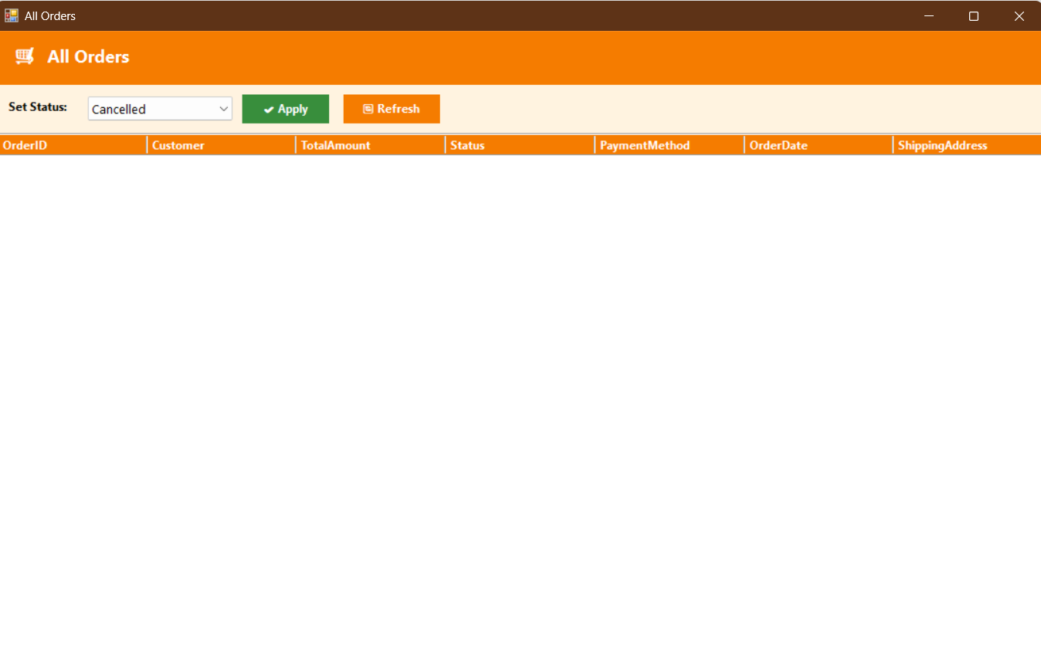
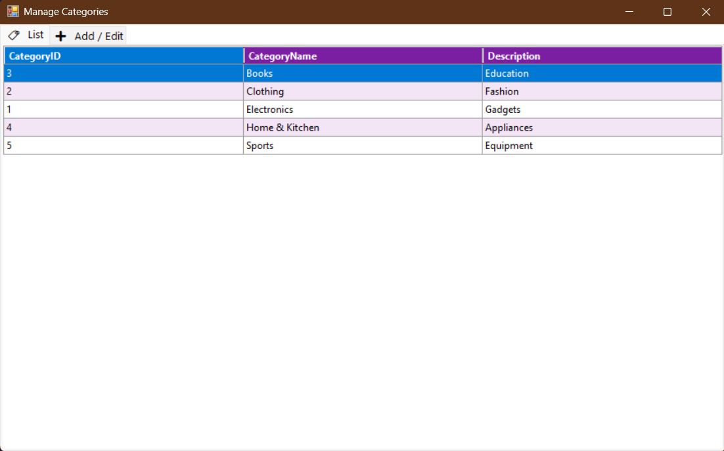
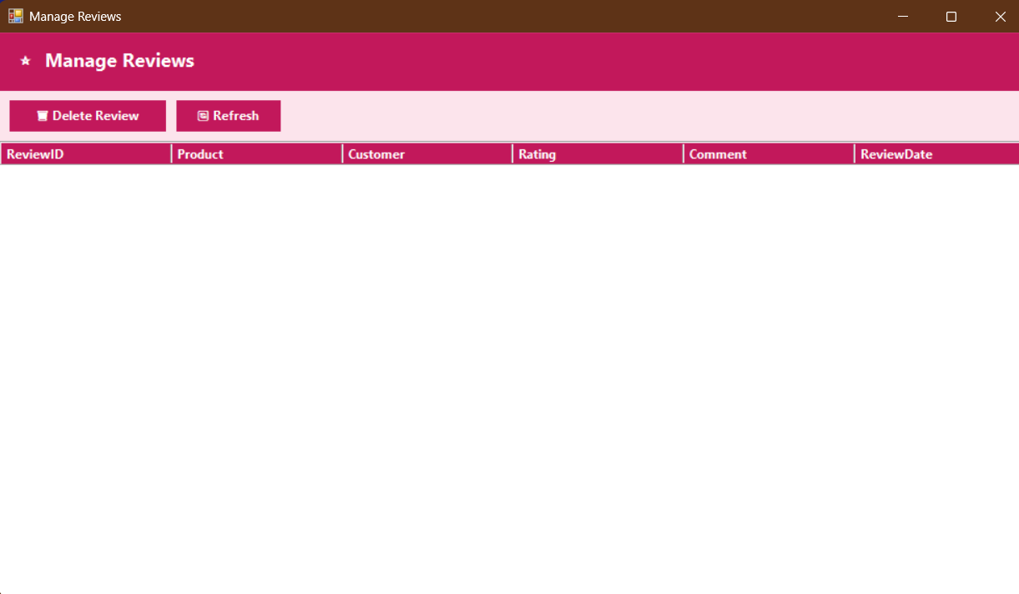
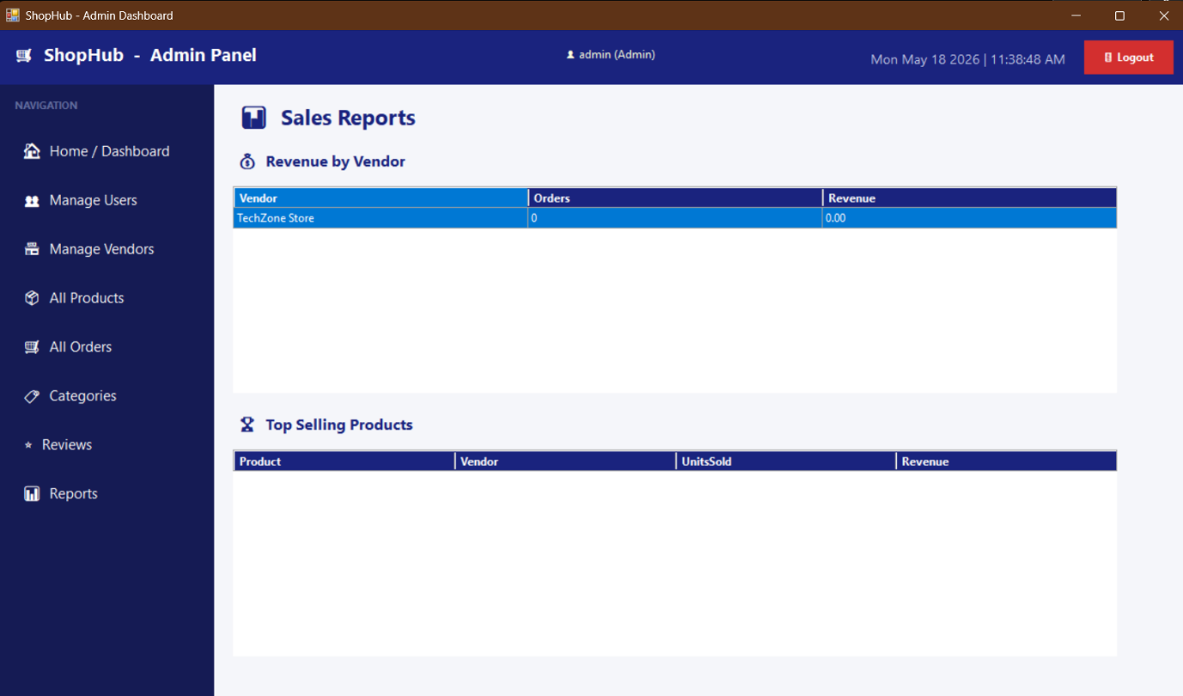
Figure 03: Admin Controls

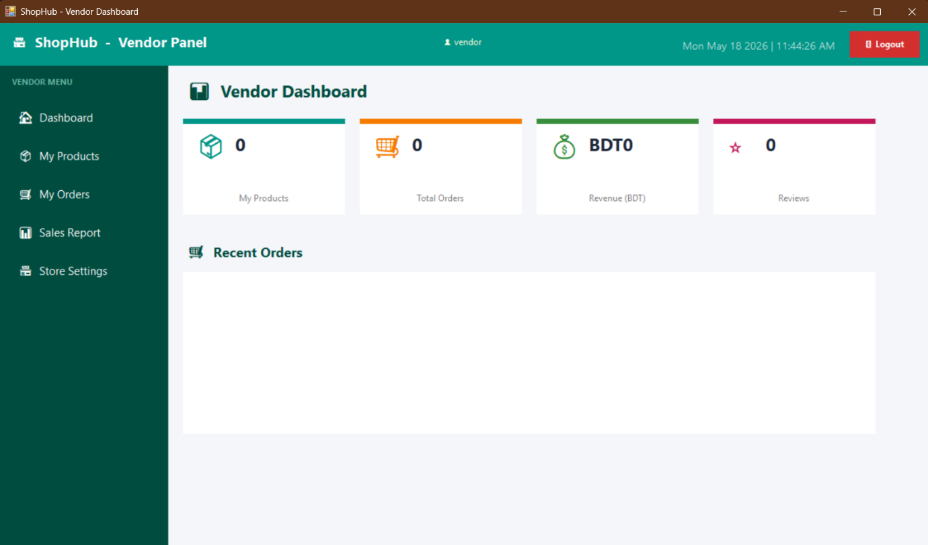
Figure 04: Vendor Dashboard

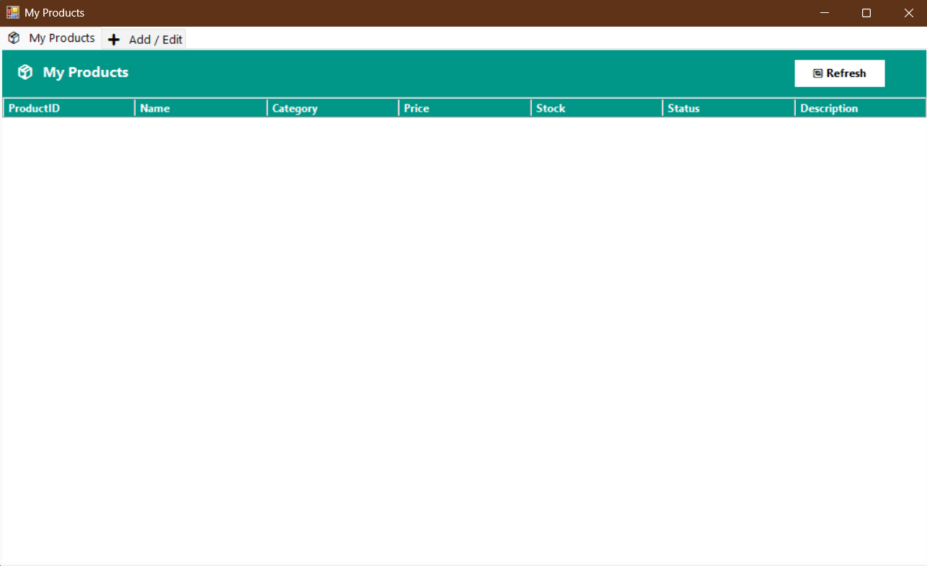
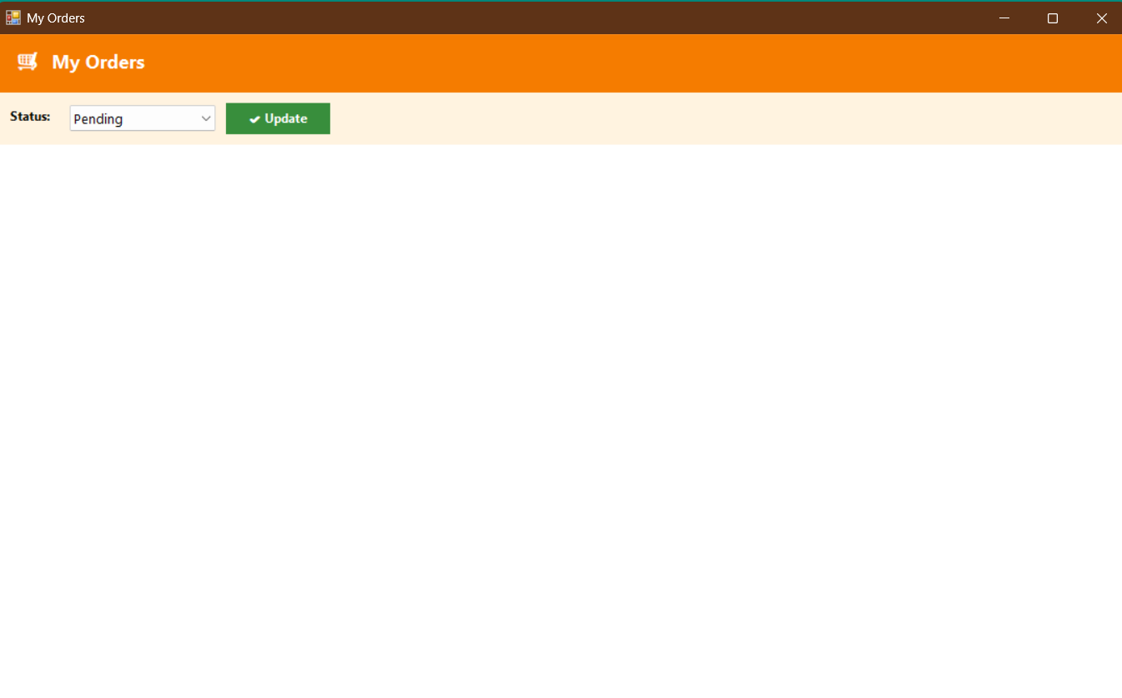
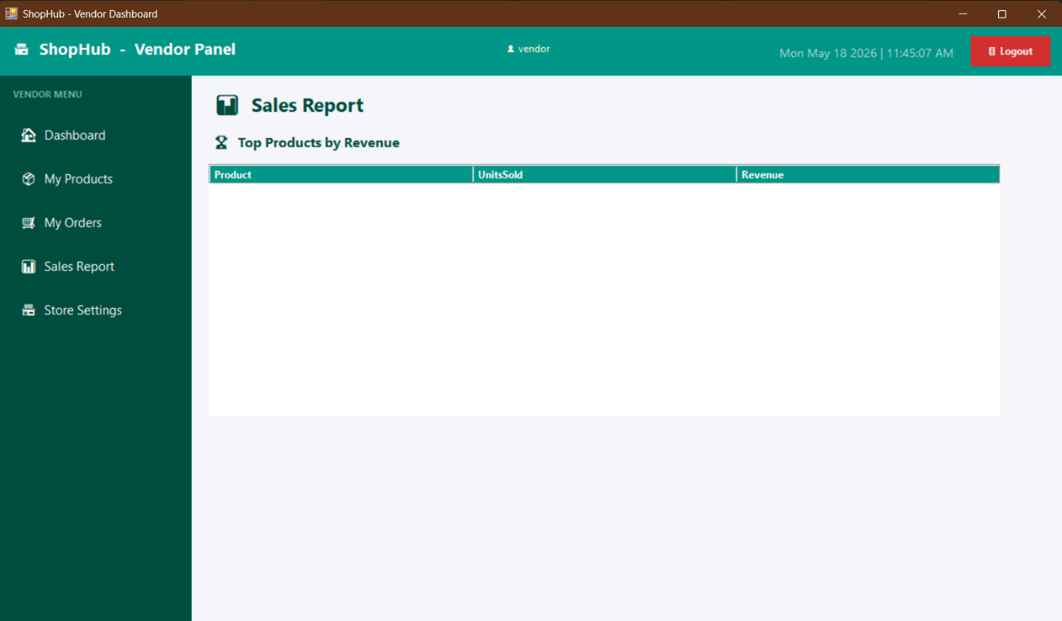
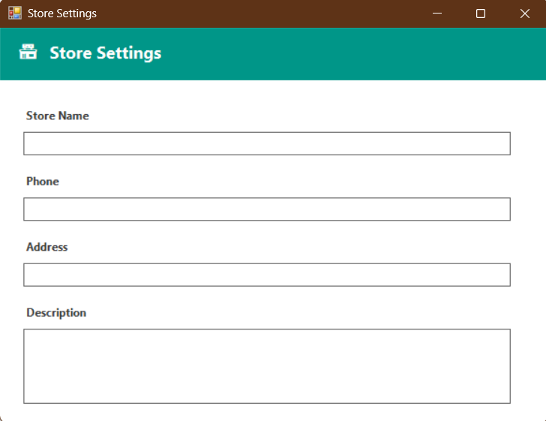
Figure 05: Vendor Controls

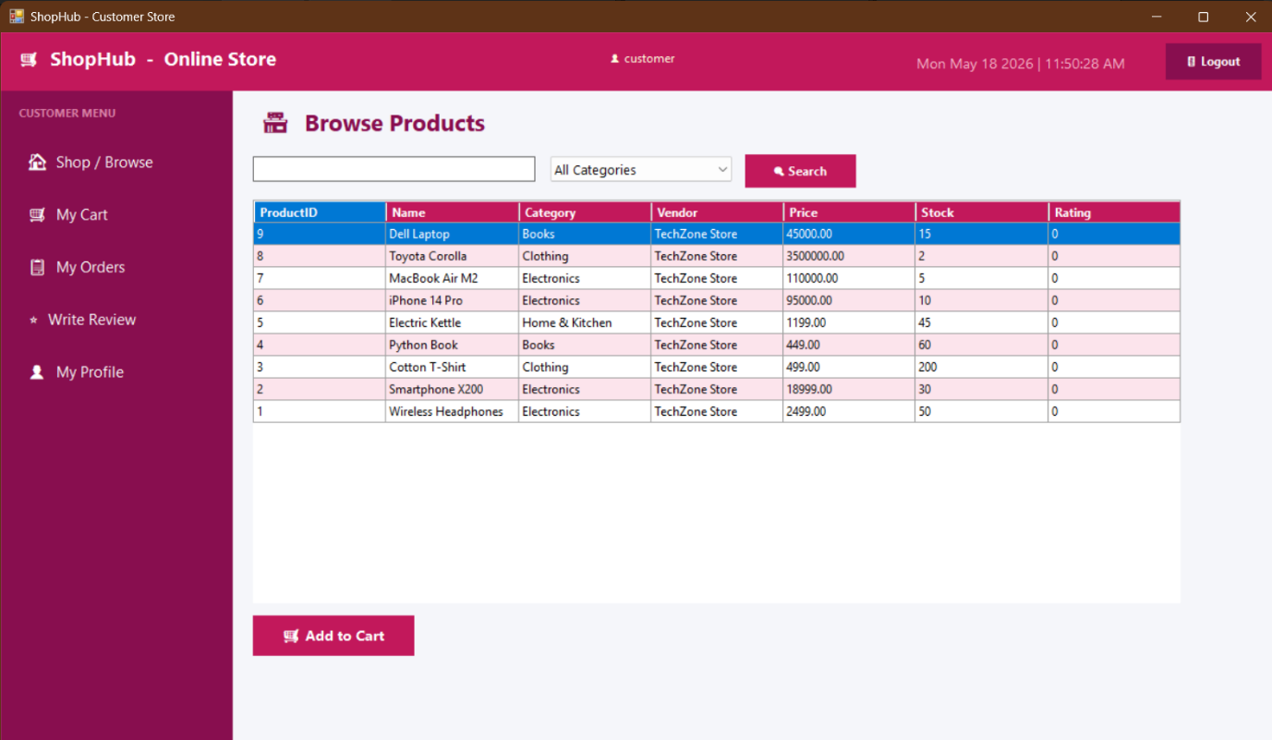
Figure 06: Customer Dashboard

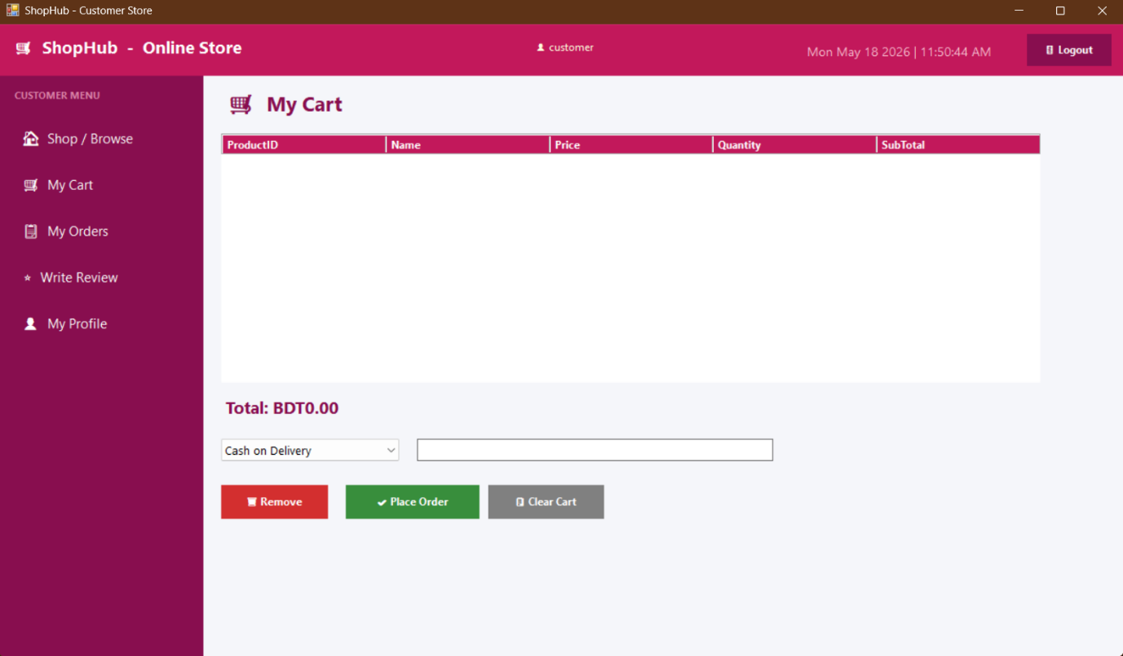
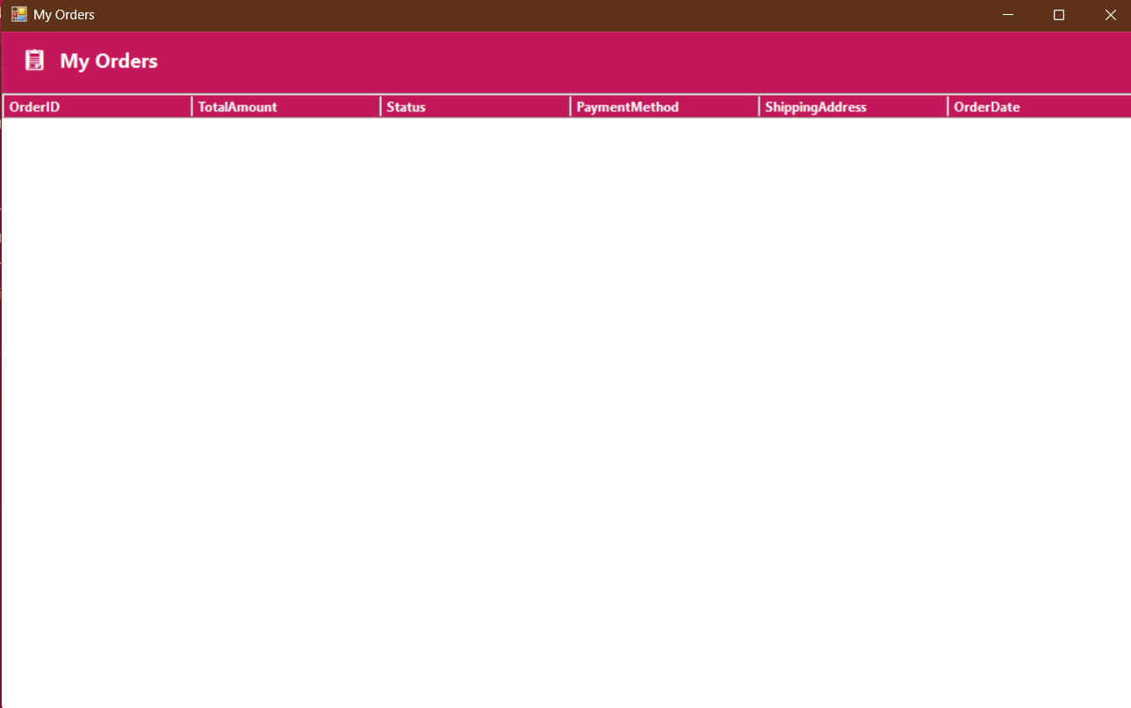
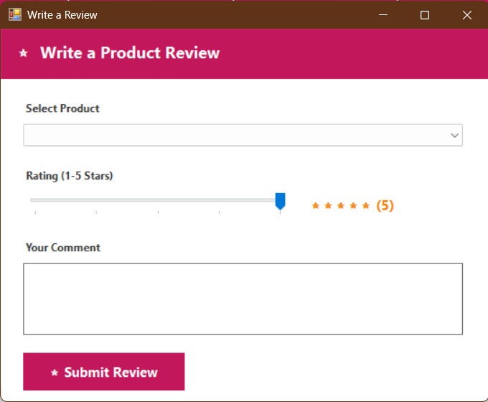
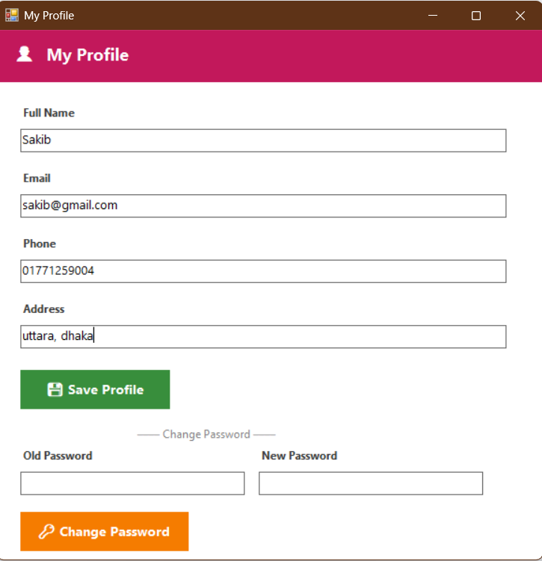
Figure 07: Customer Access

